|  |
| --- |
| Объектно-реляционные базы данных. Проектирование и создание |

1. **Вариант задания (12 вариант)**

Вакансии: волонтерские позиции, название вакансии, организация работодатель, адрес работодателя, диапазон зарплаты, требования к образованию, Обязанности, график работы, требования обязательные, желательные, дата выставления вакансии.

а. вакансии, имеющие в названии SQL, но не заканчивающиеся на него

б. работодатели в Санкт-Петербурге, выставившие несколько вакансий

в. вакансия с наибольшей зарплатой

г. волонтерские позиции с максимальным количеством требований

д. вакансии, в которых нет требования к опыту работы

2. **Физическая модель базы данных:** 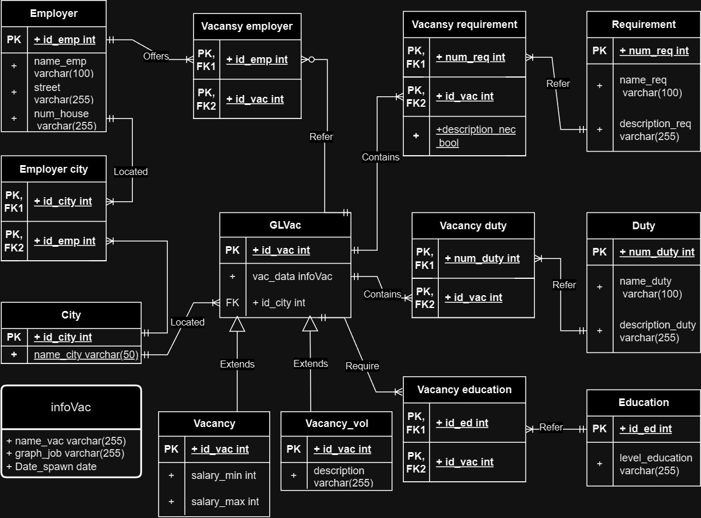

1. **Созданная модель базы данных:**

CREATE TYPE infoVac AS (

name_vac VARCHAR(255),

graph_job VARCHAR(255),

date_spawn DATE

);

CREATE TABLE IF NOT EXISTS Employer(

id_emp SERIAL NOT NULL PRIMARY KEY,

name_emp VARCHAR(100) NOT NULL,

street VARCHAR(255) NOT NULL,

num_house VARCHAR(255) NOT NULL

);

CREATE TABLE IF NOT EXISTS City(

id_city SERIAL NOT NULL PRIMARY KEY,

name_city VARCHAR(50) NOT NULL

);

CREATE TABLE IF NOT EXISTS Employer_city(

id_city INT NOT NULL,

id_emp INT NOT NULL,

FOREIGN KEY (id_city) REFERENCES City(id_city) ON DELETE CASCADE ON UPDATE RESTRICT,

PRIMARY KEY (id_city, id_emp)

);

CREATE TABLE IF NOT EXISTS GLVac(

id_vac SERIAL NOT NULL,

vac_data infoVac NOT NULL,

id_city INT NOT NULL,

FOREIGN KEY (id_city) REFERENCES City(id_city) ON DELETE CASCADE ON UPDATE RESTRICT,

PRIMARY KEY (id_vac)

);

CREATE TABLE IF NOT EXISTS Vacancy(

salary_min INT,

salary_max INT,

FOREIGN KEY (id_city) REFERENCES City(id_city) ON DELETE CASCADE ON UPDATE RESTRICT,

PRIMARY KEY (id_vac)

) INHERITS (GLVac);

CREATE TABLE IF NOT EXISTS Vacancy_vol(

description varchar(255) NOT NULL,

FOREIGN KEY (id_city) REFERENCES City(id_city) ON DELETE CASCADE ON UPDATE RESTRICT,

PRIMARY KEY (id_vac)

) INHERITS (GLVac);

CREATE TABLE IF NOT EXISTS Vacancy_employer(

id_emp INT NOT NULL,

id_vac INT NOT NULL,

FOREIGN KEY (id_emp) REFERENCES Employer(id_emp) ON DELETE CASCADE ON UPDATE RESTRICT,

PRIMARY KEY (id_emp, id_vac)

);

CREATE TABLE IF NOT EXISTS Requirement(

num_req SERIAL NOT NULL,

name_req VARCHAR(100) NOT NULL,

description_req VARCHAR(255) NOT NULL,

PRIMARY KEY (num_req)

);

CREATE TABLE IF NOT EXISTS Vacancy_requirement(

num_req INT NOT NULL,

id_vac INT NOT NULL,

description_nec BOOLEAN NOT NULL,

FOREIGN KEY (num_req) REFERENCES Requirement(num_req) ON DELETE CASCADE ON UPDATE RESTRICT,

PRIMARY KEY (num_req, id_vac)

);

CREATE TABLE IF NOT EXISTS Duty(

num_duty SERIAL NOT NULL,

name_duty VARCHAR(100) NOT NULL,

description_duty VARCHAR(255) NOT NULL,

PRIMARY KEY (num_duty)

);

CREATE TABLE IF NOT EXISTS Vacancy_duty(

num_duty INT NOT NULL,

id_vac INT NOT NULL,

FOREIGN KEY (num_duty) REFERENCES Duty(num_duty) ON DELETE CASCADE ON UPDATE RESTRICT,

PRIMARY KEY (num_duty, id_vac)

);

CREATE TABLE IF NOT EXISTS Education(

id_ed SERIAL NOT NULL,

level_education VARCHAR(255) NOT NULL,

PRIMARY KEY (id_ed)

);

CREATE TABLE IF NOT EXISTS Vacancy_education(

id_ed INT NOT NULL,

id_vac INT NOT NULL,

FOREIGN KEY (id_ed) REFERENCES Education(id_ed) ON DELETE CASCADE ON UPDATE RESTRICT,

PRIMARY KEY (id_ed, id_vac)

);

--____________________________________________________________________________

CREATE OR REPLACE FUNCTION check_VacReqVacEdVacDutyVacEmp()

RETURNS TRIGGER AS $$

BEGIN

UPDATE Vacancy_requirement SET id_vac = NEW.id_vac

WHERE id_vac=old.id_vac;

UPDATE Vacancy_education SET id_vac = NEW.id_vac

WHERE id_vac=old.id_vac;

UPDATE Vacancy_duty SET id_vac = NEW.id_vac

WHERE id_vac=old.id_vac;

UPDATE Vacancy_employer SET id_vac = NEW.id_vac

WHERE id_vac=old.id_vac;

RETURN NEW;

END;

$$ LANGUAGE plpgsql;

--___________________________________________________________________________________________

CREATE OR REPLACE FUNCTION check_delVacReqVacEdVacDutyVacEmp()

RETURNS TRIGGER AS $$

BEGIN

DELETE from Vacancy_requirement

WHERE id_vac= old.id_vac;

DELETE from Vacancy_education

WHERE id_vac=old.id_vac;

DELETE from Vacancy_duty

WHERE id_vac=old.id_vac;

DELETE from Vacancy_employer

WHERE id_vac=old.id_vac;

RETURN NEW;

END;

$$ LANGUAGE plpgsql;

CREATE TRIGGER updForeignInsGLVac

AFTER UPDATE OF id_vac ON GLVac

FOR EACH ROW

EXECUTE FUNCTION check_VacReqVacEdVacDutyVacEmp();

CREATE TRIGGER delForeignInsGLVac

BEFORE DELETE ON GLVac

FOR EACH ROW

EXECUTE FUNCTION check_delVacReqVacEdVacDutyVacEmp();

--____________________________________________________________________________

CREATE OR REPLACE FUNCTION check_VacAndVacVol()

RETURNS TRIGGER AS $$

BEGIN

IF NOT EXISTS (SELECT 1 FROM GLVac WHERE id_vac = NEW.id_vac) THEN

RAISE EXCEPTION 'GLVac with id % does not exist', NEW.id_vac;

END IF;

RETURN NEW;

END;

$$ LANGUAGE plpgsql;

CREATE TRIGGER checkGLVacInsVacEmp

BEFORE INSERT OR UPDATE ON Vacancy_employer

FOR EACH ROW

EXECUTE FUNCTION check_VacAndVacVol();

--____________________________________________________________________________

CREATE TRIGGER checkGLVacInsVacReq

BEFORE INSERT OR UPDATE ON Vacancy_requirement

FOR EACH ROW

EXECUTE FUNCTION check_VacAndVacVol();

--____________________________________________________________________________

CREATE TRIGGER checkGLVacInsVacDuty

BEFORE INSERT OR UPDATE ON Vacancy_duty

FOR EACH ROW

EXECUTE FUNCTION check_VacAndVacVol();

--____________________________________________________________________________

CREATE TRIGGER checkGLVacInsVacEd

BEFORE INSERT OR UPDATE ON Vacancy_education

FOR EACH ROW

EXECUTE FUNCTION check_VacAndVacVol();